Home Help Activity Badge
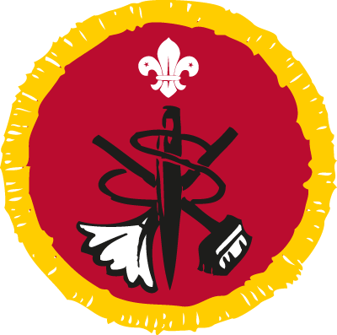
How to earn your badge
- Plan, cook and serve a simple one-course meal.
- Wash up afterwards. Show how to clean a saucepan or other cooking utensils, cutlery and glasses. You could use a dishwasher for this step, including loading and unloading it.
- Help sort out the washing. Load and unload the washing machine.
- Iron at least two items. They could be things like pillowcases, t-shirts or trousers.
- Sew on a button.
- Help to clean and tidy a living room.
- Clean at least two items in your home. They could be things like a basin or kitchen cupboard, silverware or brass.
- Take sheets, pillow covers and the duvet cover off a bed and help to put clean ones on. Make your own bed for a week.

I confirm that................................................................has met the above stated requirements for the Home Help Badge.

Signed..........................................................................

Date ......./......../...........

Print Name...........................................................................................

